**UI**

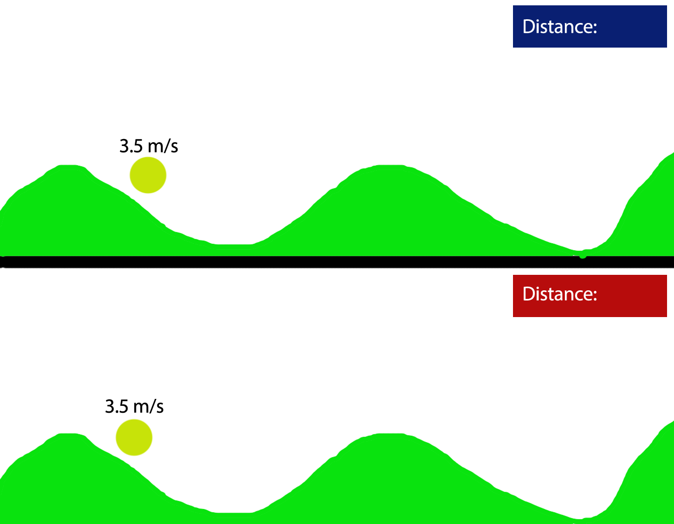

The UI in this game is quite simplistic because there is very little information the players need to see. Both players run along an identical track to see who can get the furthest before stopping. For this reason the only information that players NEED is the distance they have covered to know who has gone further.

This information needs to be clear to the player. Firstly it is measured in meters which is the standardised measure of distance in science and indeed for most people so there wont be any confusion by what it means, and what it represents. The information is displayed in boxes of different colours to make them contrast the rest of the screen and make the text within them easy to read.

I have also decided to give the players information on their speed to help them draw their own conclusions on how uncertain and inevitable the game is. They can see when the game is coming to an end when the speed gets lower.

If we do implement a speed boost pickup then this information also acts as an affordance as the link between the pickup and increasing your speed becomes more obvious when the player can see their speed value increase accurately by the number.

I am also going to create Congratulation popups to show to the player when they achieve certain milestones, distance will be rewarded with these popups and should act as a further affordance as getting distance means you are not stopped as a player piece and therefore have not lost, by encouraging players to seek distance they are being encouraged to win the game, or at least shown how.

The speed statistic will follow the player piece to ensure players realise they are linked and that the speed in value (in meters per second for the same reason as the distance being in meters) is attributed to the player piece.